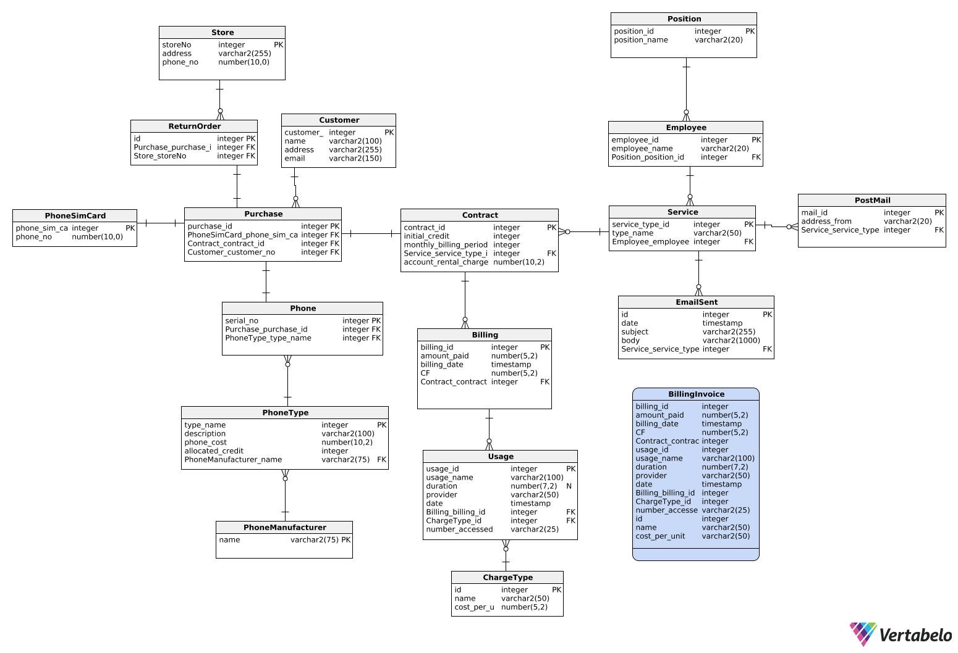**MyPhone Schema**

**Thought process while creating your ERD**

A customer can make many purchases. Each purchase will be of one phone with one contract. When a customer purchases a phone, they will get a phone sim card. Depending on which phone type they purchase they will get specific allocated created. A phone manufacturer can have many different phone types Nokia 6510 and Nokia 1121. Each phone can be uniquely identified by its serial number.

Each purchase of a phone will have one contract. A purchase/contract can be made via walk-in or online. A online or walk in service type is performed by an employee. If the service type is online an email will be sent and it package will be posted. Employees can have different positions (backroom staff, billing staff and retail staff) and each perform different services.

The contract table has a monthly billing period in days (60 days average), account rental charge (€20 every 60days) and an initial credit field which is the minus figure of allocatedcredit field in the phone type table. In the billing table, when a customer pays money off their bill it is put into amount_paid field. To calculate the CF (add up all the usage cost, add monthly rental charge and last CF) minus amount paid off bill by customer.

We created 4 different charge types voice calls, myphone sms, other networks sms and downloads. All of these had different cost per unit. Any local calls will start with +353 and will be charged standard rate. If a voice call hasn’t +353 the duration will be multiplied by the cost per unit.